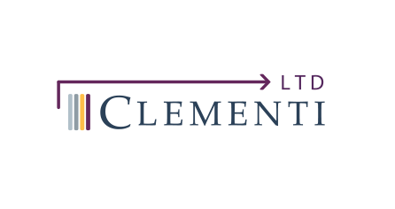 | Clementi and Associates Company Website 2026 | Draft 17-Apr-2026

General Notes:
- Simple one page scrolling website with main locked header banner
- Header banner with drop-down links to subheadings below. Need ultimately confirm the dropdowns form top header banner
- Sample Sites:
- Regulatory Intelligence | Redica Systems
- Solve Therapeutics (main reference site)
- Hand is motif: Need to make this more apparent
- Animations: )White rotating molecules on Overview slide (should be drafted by Tues 21st)
Gears (under overview on Overview slide (draft in place)
Clementi Logo Build on Who We Are slide(should be drafted by Tues 21st)
Chemistry CMC word cluster animation. I need to find best place to insert drafted
Audit word cluster animation (coming)
Add eCTD Pyramid animation puzzle <Laurie can create>
- Footer Banners: Would like to have the present images and additional images as scrolling horizonal strip (direction left). Additional images need to be added.

Home

Headline
Expert Medical and Regulatory Affairs Consultants

Subheadline
Supporting innovators from early development through approval with deep expertise in CDER, CBER, cell-based therapies, and novel biologics.

Overview
We are a specialized regulatory affairs consulting group dedicated to helping pharmaceutical, biotechnology, and advanced therapy companies navigate complex regulatory pathways. With deep experience in Good Manufacturing Practice (GMP), Good Laboratory Practice (GLP), and FDA submissions, we provide strategic and operational support across the product lifecycle.
Our team has extensive experience working with the FDA, including submissions to the Center for Drug Evaluation and Research (CDER) and the Center for Biologics Evaluation and Research (CBER), with particular expertise in cell and gene therapies, tissue-based products, and novel biologics.
Gear Animation
Each Gear Represents a service (listed by Importance and shape:
- Main Gear: eCTD IND
- CMC
- Toxicology
- Clinical Protocol
- Document Management
- FDA Meetings
- GLP
- Monitoring Audits

What We Do

Our Mission (top heading banner dropdown)
To accelerate the development and approval of innovative therapies by providing clear, strategic, and compliant regulatory guidance.

Therapeutic Focus
- Cell and gene therapies
- Monoclonal antibodies
- Recombinant proteins
- Vaccines
- Tissue-engineered products

Regulatory Strategy
We develop tailored regulatory strategies aligned with your product type, development stage, and commercial goals.
- Regulatory pathway assessment (CDER vs CBER)
- Orphan drug, RMAT, and expedited program strategies
- Global regulatory alignment

Expertise
Our consultants bring decades of combined experience in regulatory affairs, quality systems, and product development. We have successfully supported:
- IND and BLA submissions for biologics and advanced therapies
- GMP facility readiness and inspections
- GLP study design and compliance

Services (top heading banner dropdown)
<Word scramble animation> Clean up spelling Possible place for this animation.

FDA Submissions
We provide end-to-end support for regulatory submissions.
- Pre-IND and INTERACT meetings
- IND applications
- NDA and BLA submissions
- Amendments, supplements, and annual reports

Document Management
- Maintenance of Full Regulatory History
- Manage ESG Client Accounts
- Secure Cloud Project, Workflows, and Task Manager
- Current XML eCTD Publisher and Validator
- Preparation of Submission-Ready Compliant Documents
- Document Management System (Cloud and Premises)
- Off-site Multiple Backup Systems (Cloud)

CMC Development
We support Chemistry, Manufacturing, and Controls (CMC) development for complex biologics and cell-based products.
- Process development and scale-up
- Analytical method development
- Stability programs
- CMC documentation for IND/BLA

Advanced Therapies
Specialized support for cutting-edge therapeutics.
- Cell and gene therapy products
- ATMP regulatory strategy
- Comparability and potency assays
- Vector manufacturing and control strategies
- Document Management

GxP Compliance

GCP

GLP
Support for nonclinical studies to meet regulatory standards.
- Study protocol review
- GLP compliance audits
- Vendor qualification
- Data integrity assessments

GMP
Ensure your manufacturing operations meet FDA expectations.
- Quality system design and remediation
- SOP development
- Batch record review
- Mock inspections and audit readiness

GDP

FDA Expertise

CDER Experience
We support small molecule drugs and certain biologics regulated by CDER, including:
- IND and NDA preparation
- Clinical development strategy
- Labeling and regulatory compliance

CBER Experience
Deep expertise in biologics and advanced therapies regulated by CBER:
- Cell and gene therapies
- Vaccines
- Blood and tissue products
- BLA submissions and lifecycle management

FDA Interactions
We help you communicate effectively with FDA:
- Meeting briefing documents
- Meeting strategy and rehearsals
- Post-meeting follow-up and commitments

Who We Are (see separate folder organized by person)
Clementi Logo: Animation with Logo on Who we Are or Meet the Team Page
Include (Left to Right):
Cards flip upon Scrolling Down in measured speed (not clicking)
On the back or “non-face” side of card, have title of individual listed
Have all bios and 3 out of 4 photos.

Card 1
William A. Clementi, Pharm.D., F.C.P.
Founder and Chief Regulatory Officer
President
Photo is accurate
Working Bio

Card 2
Nancy Durst Clementi, M.D
Chief Medical Officer
<needs new photo>

Card 3
Paul Heslin <additional degrees?> M.B.A
<Title>

Card 4
David L. Sloane, Ph.D.
Senior Director cGMP Manufacturing (correct?)
Bio is up-to-date

FAQs
Need to confirm content for this.

Contact Us

Get in Touch
Ready to advance your program? Contact us to discuss how we can support your regulatory strategy and compliance needs.
Email: info@regulatoryaffairs.com
Phone: (610) 527-2600
919 Conestoga Rd.
Bryn Mawr, PA
19010
USA

Request a Consultation
Fill out our contact form and one of our experts will reach out to you shortly.
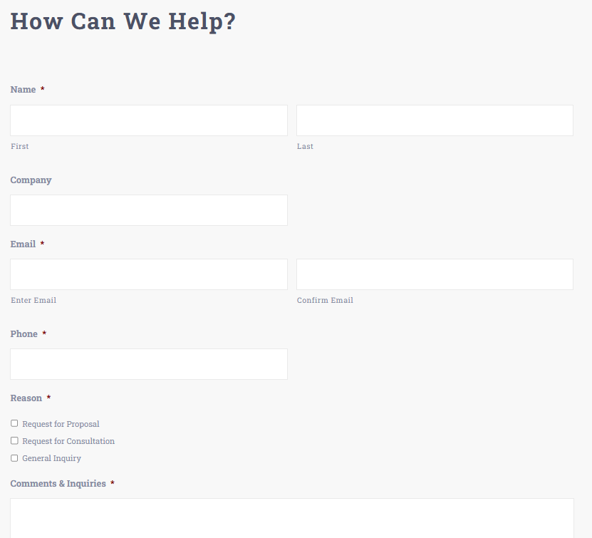
Add to above:
Request a CDA
Request a Master Services Agreement

